Raisin Pancake Squares
These pancakes turn out square because you make them in a baking pan.
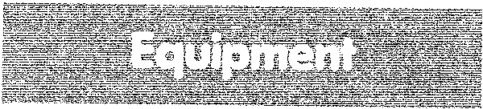
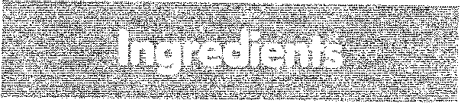
Measuring cups and spoons
Paper towel or waxed paper 15xlOx1-inch baking
pan
Table knife
Medium mixing bowl Wooden spoon Rubber scraper
Hot pads
Pancake turner
Shortening
1 egg
2 cups packaged pancake mix
1 1/2 cups milk
2 tablespoons cooking oil
1 teaspoon ground cinnamon
1/2 cup raisins or mixed dried
fruit bits
Margarine or butter (if you like)
mapleflavored syrup
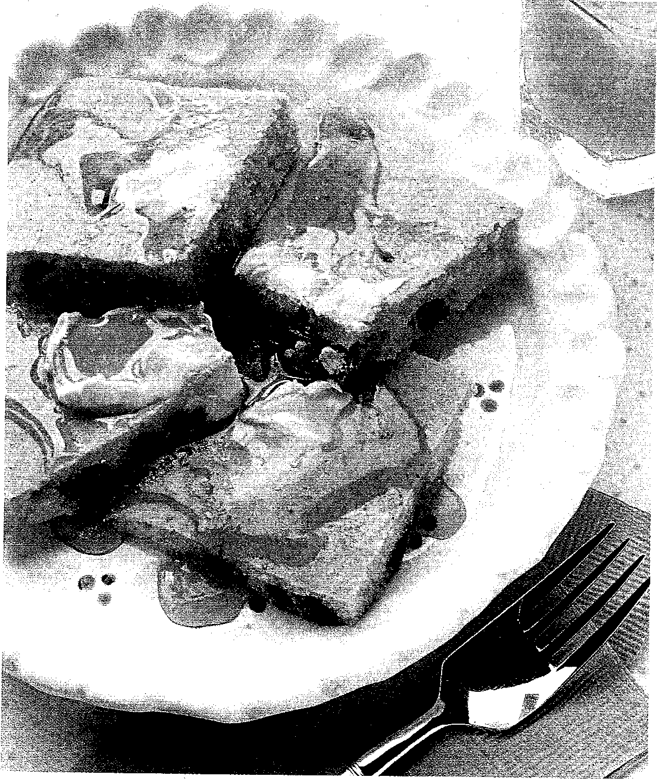
Turn the oven to 425⁰• Put some shortening on a piece of
paper towel or waxed paper. Spread the shortening over the bottom of the baking pan. Save until Step 3.
Crack the egg into the mixing bowl. Add the
pancake mix, milk, cooking oil, and cinnamon. Stir with the wooden spoon till the dry ingredients are wet. (The batter should have small lumps, so don't stir too much.) Stir in raisins or dried fruit bits.
Pour the batter into the greased baking pan. Use the
rubber scraper to scrape all of the batter from the mixing bowl into the pan. Spread the batter evenly in the pan.
Put the pan in the oven. Bake about 10 minutes or
till the edges are light brown and the top springs back when you lightly touch it with your finger. Use hot pads to remove the pan from the oven. Cut into 6 squares. Then, cut each square into 4 smaller squares. Lift the squares from the pan using the pancake turner. Spread with margarine or butter, if you like. Serve with syrup. Serves 6.

